2017

Github Live url : <https://kaustuv-praz.github.io/csy1018-assign1/>

**Assignment 1: Web Development**

**UN ID: 17421493**

**Kaustuv Prajapati**

**Portfolio Website**

Submission Date: 07-APR-2017

Summary

This report is about the personal website that I have created. It is a portfolio website which includes my relevant personal information. The website is completely based on HTML-5 and CSS-3 codes, apart html and css no languages are used. This web site is created by observing several other professional websites, but the Non of the code that is used to create this website is copied or derived from elsewhere. Atom text Editor is used for coding.

|  |  |  |
| --- | --- | --- |
| SN. | Topic | Page No. |
| 1 | Introduction | 1 |
| 2 | Developing This Website  Table Of Content  2.1 Designing Sketch  2.1.1 Home Page Sketch  2.1.2 Home page sketch tablet and mobile  2.1.3 Biography Page desktop view Sketch  2.1.4 Contact Page Sketch  2.1.5 CV Page Sketch  2.2 Designing Wire Frames  2.2.1 Home Page Wire Frame  Desktop View  Tablet View  Mobile View  2.2.2 Wire Frame for Bio and Contact pages(desktop view)  2.2.3 Bio Page Tablet and Mobile View  2.2.4 Wire Frame for CV page.(desktop view)  2.3 Prototype Development  2.3.1 -1st week of project development  2.3.2 -2nd week of project development  2.3.3 -3rd week of project development  2.3.4 -4th week of project development  2.3.5 -5th week of project development  2.4 Error Handling  2.4.1 Header And Footer  2.4.2 CSS Errors  2.5 Testing | 2-21  2-6  2  3  4  5  6  7-12  7-9  7  8  9  10  11  12  13-19  13  14  15-17  18-19  20  21-22  21  22  23 |
| 3 | Prototypes  3.1 Home Page (index page) prototypes  3.1.1 Home Page Desktop/Laptop view(width 1024px to 1440px)  3.1.2 Home Page Tablet View (Max-width: 786px)  3.1.3 Home Page Mobile View (Width 320px to 425px)  3.2 Biography Page Prototypes  3.2.1 Biography Page Desktop/Laptop View(width 1024px to 1440px)  3.2.2 Biography page Tablet view (Max-width: 786px)  3.2.3 Biography Page Mobile View (width 320px to 425px)  3.3 CV Page Prototypes  3.3.1 CV Page Desktop/Laptop View(width 1024px to 1440px)  3.3.2 CV page Tablet view (Max-width: 786px)  3.3.3 CV Page Mobile View (width 320px to 425px)  3.4 Contact Page Prototypes  3.4.1 Contact Page Desktop/Laptop View(width 1024px to 1440px)  3.4.2 Contact page Tablet view (Max-width: 786px)  3.4.3 Contact Page Mobile View (width 320px to 425px) | 24-35  24-26  24  25  26  27-29  27  28  29  30-32  30  31  32  33-35  33  34  35 |
| 4 | Website Load Speed | 36 |
| 5 | Good practices followed to create this website  5.1 Use of Google API Fonts  5.2 Use of Compressed Image  5.3 Use of CSS-Code animations and transitions.  5.4 Used validation checking | 37  37  37  37  37 |
| 6 | Conclusion | 38 |
| 7 | References | 39 |

*Note: Page Arrangement could be disturb due to Different MS. Word version.

Here is a link for PDF version: <https://drive.google.com/open?id=0B0N-Re7hfG16aUNYVGprbXRKMU0>

1. Introduction

Rather than jumping into the sketching of website design, I visited other’s professional personal websites to built up an idea for including all the requirements in an appropriate manner. After over viewing few portfolio web pages, I roughly sketched a design on paper sheet, which I then improved in a computer sketching software “Wire Frame Sketcher”. In corresponding with the desktop view of my website I drew design for each web page(home page, bio page, cv page, contact page) that would be appropriate for the Tablet and Mobile devices.

Some of the websites that I observe in developing my own portfolio are:

* <https://joel.sh/about>
* <http://www.garysheng.com/>
* <http://www.rachaelgking.com/>

2. Developing This Website

2.1 Designing Sketch

2.1.1 Home Page Sketch

This is the 1st rough sketch design of home page (index.html page). As in the *figure 2.1.1* the page covers 100% width of the screen, thus the website is full length website. The below sketch is for desktop view( for pc and laptop).

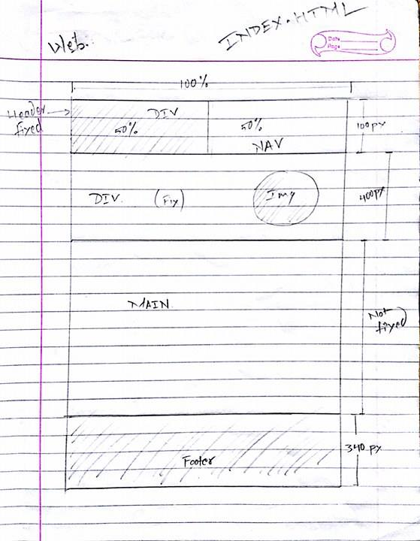.

figure 2.1.1 home page desktop view sketch

2.1.2 Home page sketch tablet and mobile

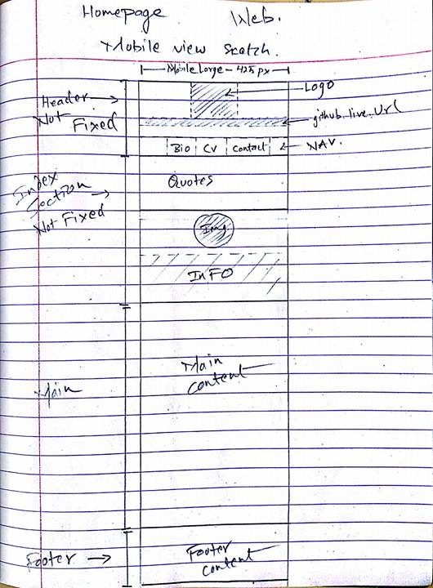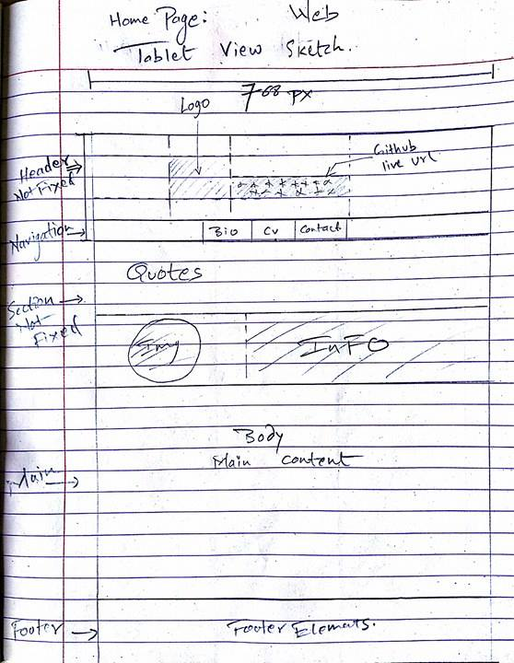

figure 2.1.3 home page mobile view sketch

figure 2.1.2 Home page tablet view sketch

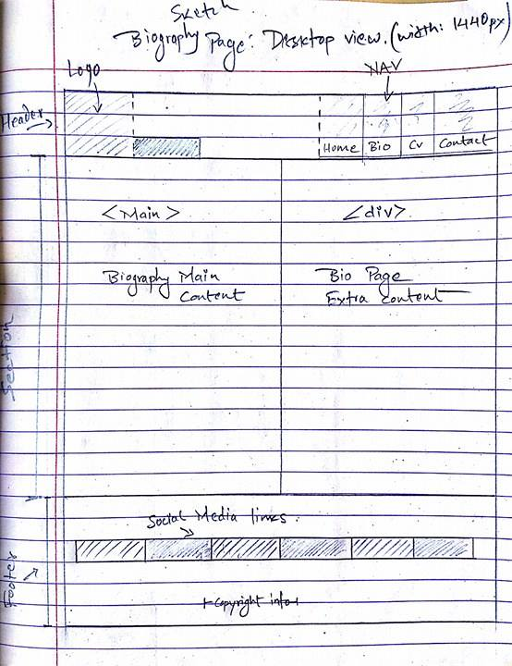2.1.3 Biography Page desktop view Sketch.

Figure 2.1.4 biography page desktop view sketch

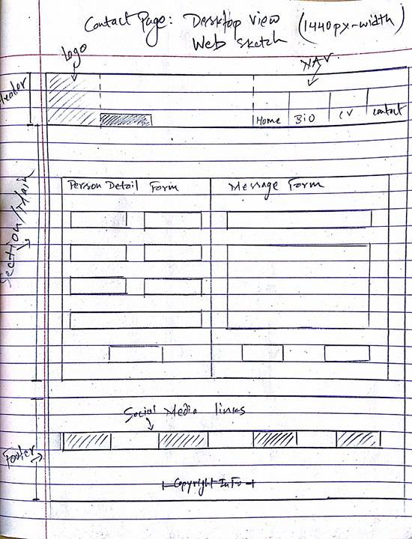2.1.4 Contact Page Sketch

Figure 2.1.5 contact page desktop view sketch

2.1.5 CV Page Sketch

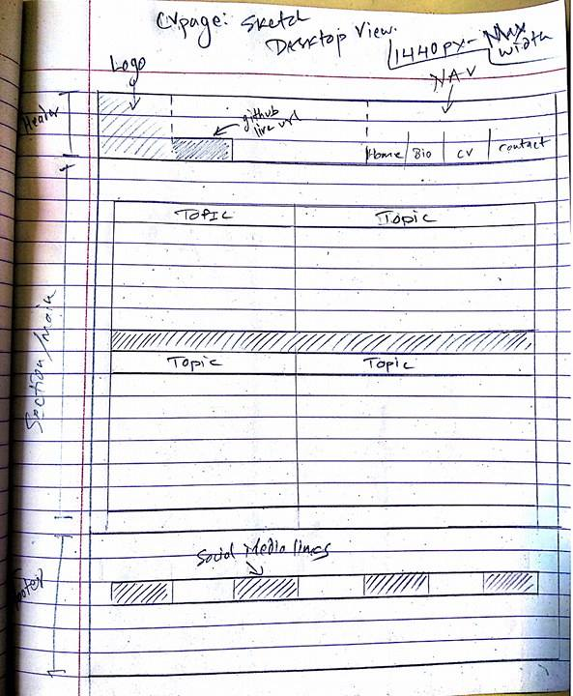

Figure 2.1.6 CV page desktop view sketch

2.2 Designing Wire Frames

2.2.1 Home Page Wire Frame

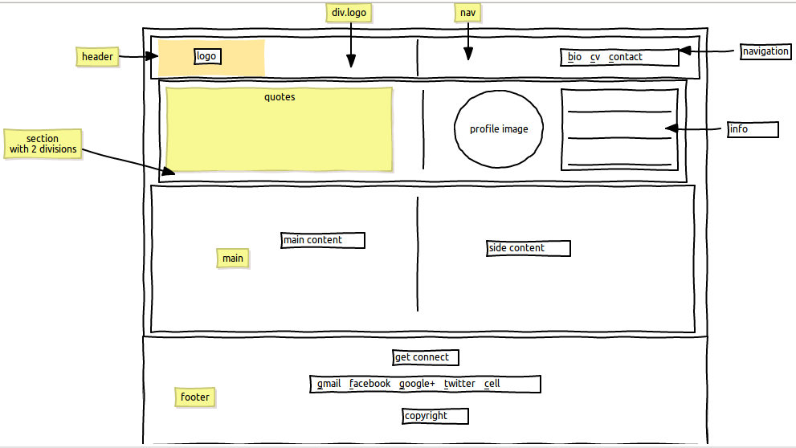Desktop view

Figure 2.2.1 wire frame of home page desktop view

Below figure 2.2.1 is a wire frame of Home page desktop view, consisting header, section, main and footer. While creating this wireframe the content were not ready.

Tablet view

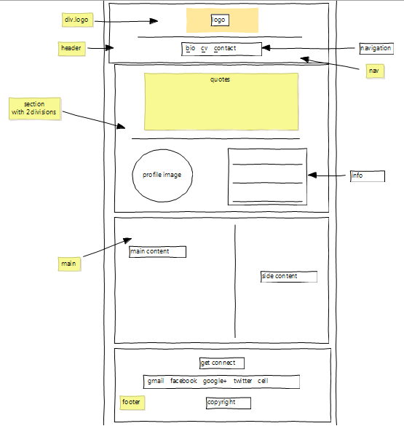Below is the wire frame of Homepage for Tablet View.

Figure 2.2.2 wire frame of home page tablet view

Mobile view

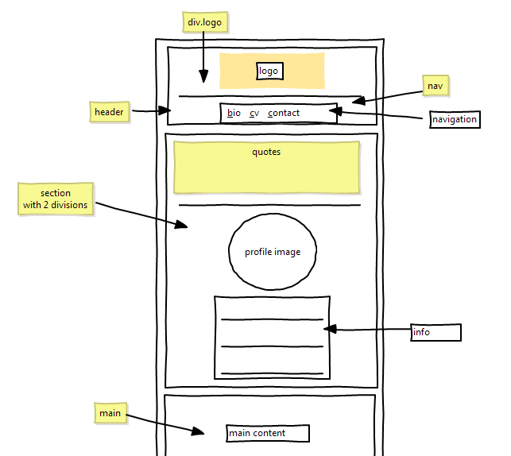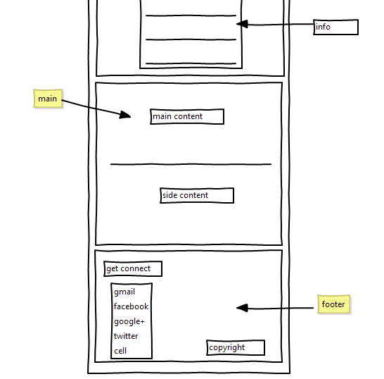Below Figure 2.2.3 is the wire frame for the home page mobile view.

Figure 2.2.3 wire frame of home page mobile view

2.2.2 Wire Frame for Bio and Contact pages.(desktop view)

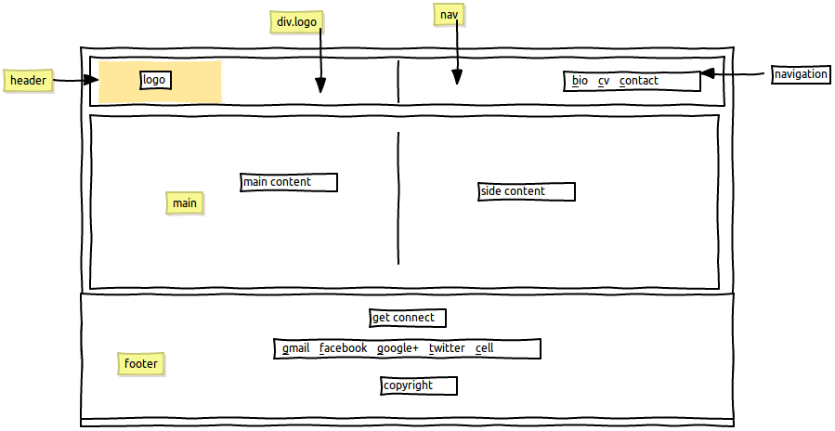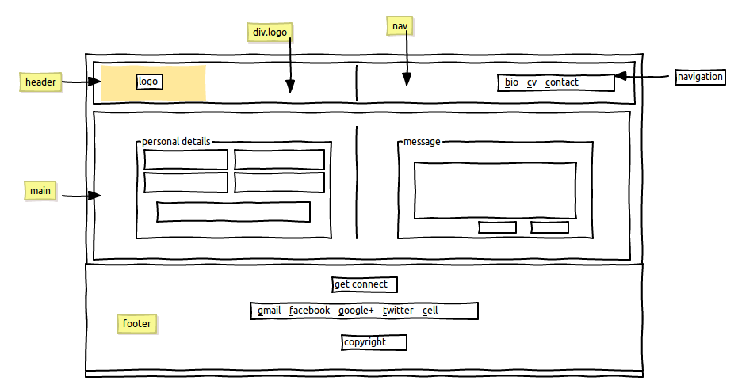Both wire frame of bio (figure 2.2.4) and contact (figure 2.2.5) are similar in context of designing layout, the only difference is their content. The Bio page contains text and image and a contact page contains contact form.

Figure 2.2.4 wire frame of bio page desktop view.

Figure 2.2.5 wire frame of contact page desktop view

2.2.3 Bio Tablet and mobile view

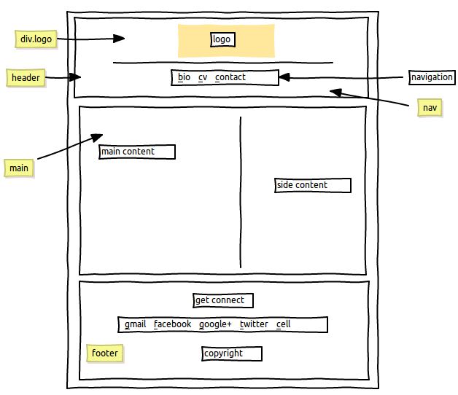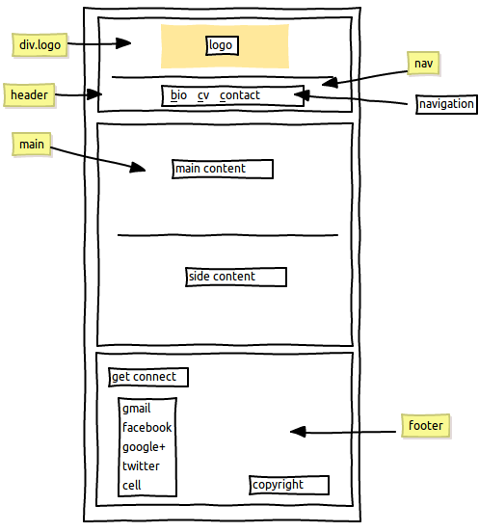

Figure 2.2.7 wire frame of bio page mobile view

Figure 2.2.6 wire frame of bio page tablet view

2.2.4 Wire frame for CV page

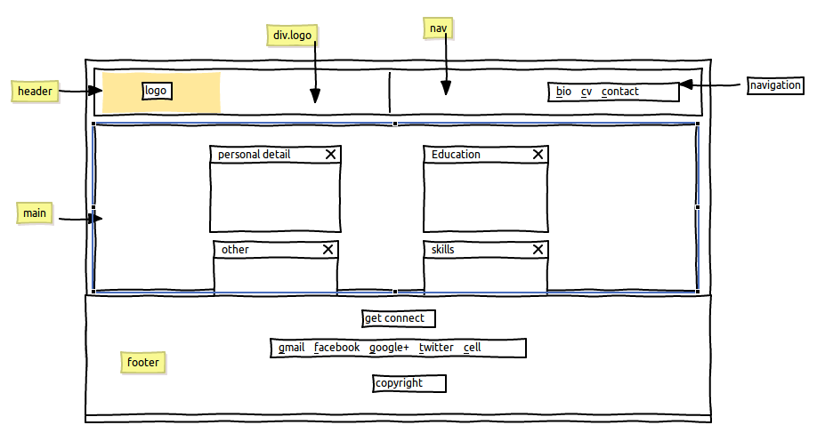CV wire frame consist of boxes for each sub element of CV.

Figure 2.2.8 wire frame of CV page desktop view

2.3 Prototype Development

The web site layout is created based on the sketch and wire frames. Some contents/elements in the prototype could be differ from the wire frame design, but the overall architectural design is based upon the wire frames.

2.3.1 1st week of project development.

Figure 2.3.1 is a screen shot image of prototype of the home page(in 1st week). Segments are not clearly distinguished.

- Things that are done in first week of project development.

* Folder management is done as required.
* Design layout of the website if formed.
* Links between the pages are established.
* 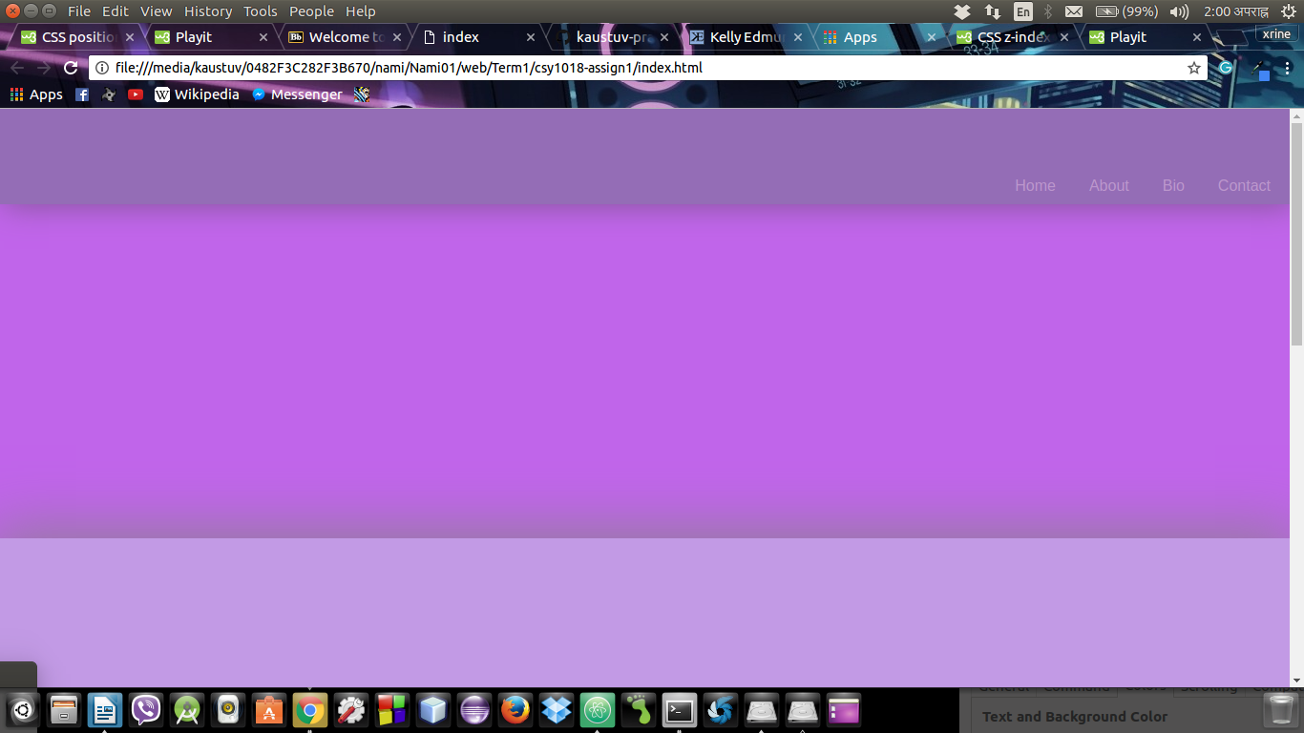Social media links and there logo are managed.

Figure 2.3.1 prototype design after 1st week of project development

2.3.2 2nd week of project development.

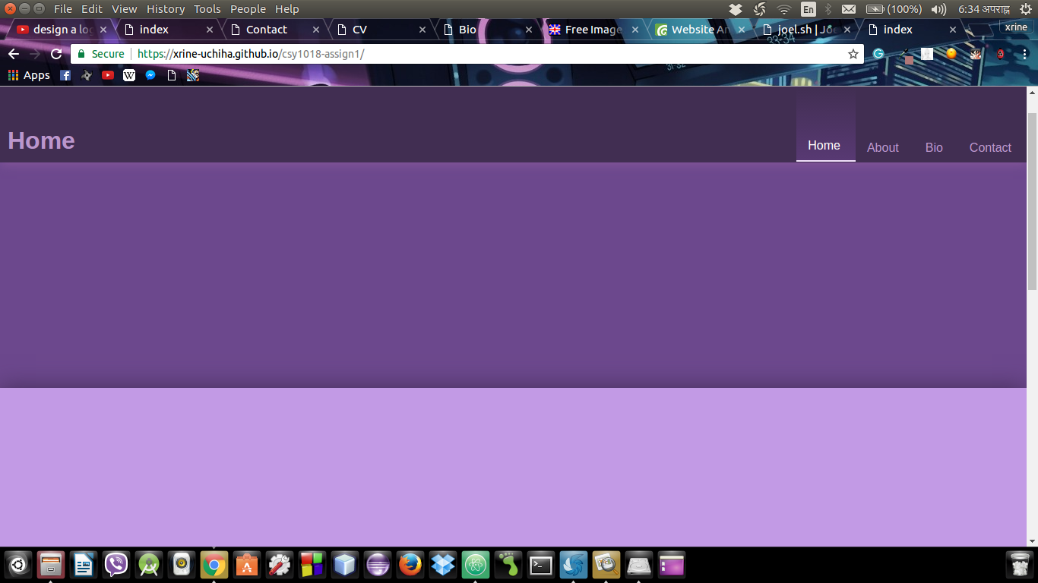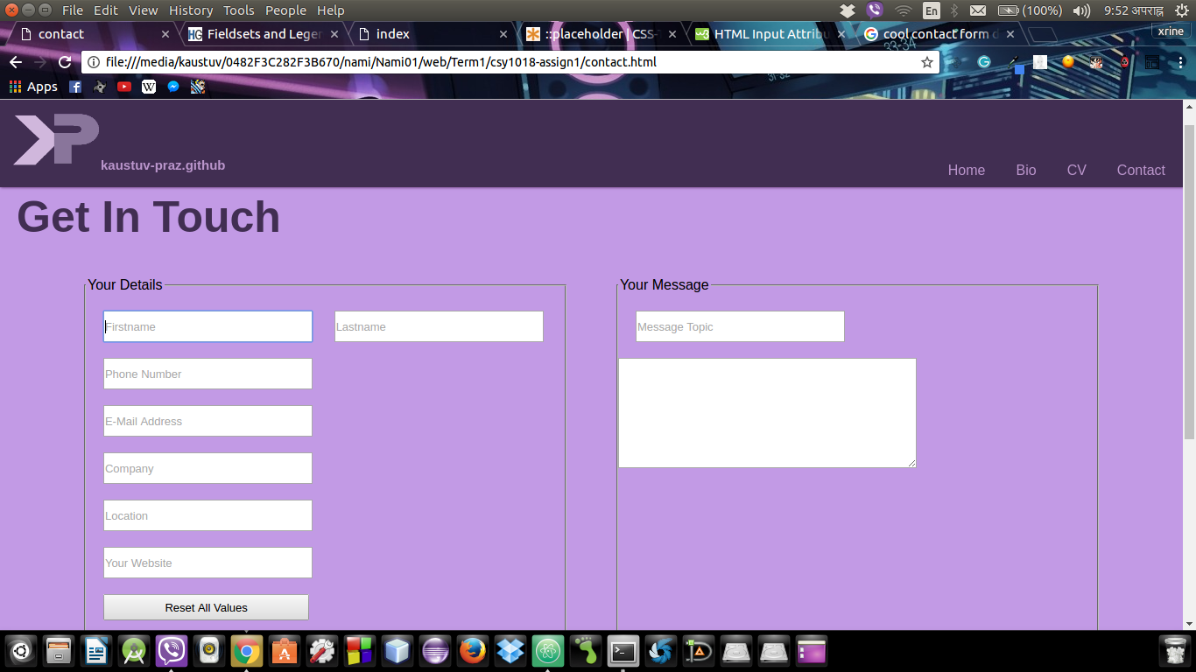In this week the major focus was on design and graphic management. Figure shows the website after 2nd week.

Figure 2.3.2 prototype design after 2nd week of project development

Figure 2.3.3 prototype design of contact page after 2nd week of project development

2.3.3 3rd week of project development.

On the 3rd week I worked on adding the content to the web site and after that I focus on making the websites responsive and Google Fonts API are added. This website is responsive to 4 different type of screens.

* Laptop or PC screen, with the high resolution of width 1025px to 1440px.
* 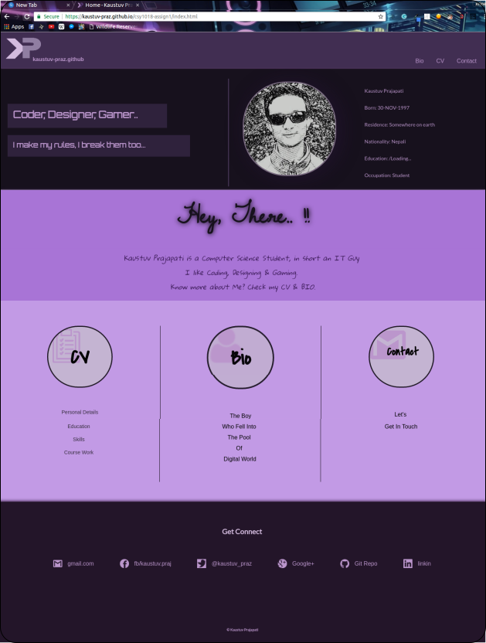Laptop or PC screen, with the low resolution of max width 1024px.

Figure 2.3.4 prototype design screenshot with media queries for laptop (1024px to 1440px)

* 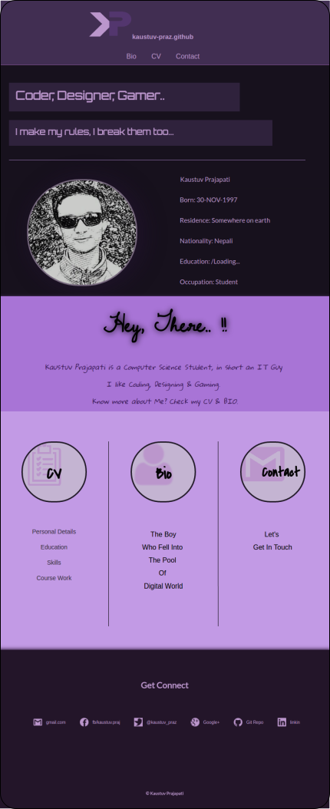Tablet view, with the screen resolution of max width 768px.

Figure 2.3.5 prototype design screenshot for tablet view (768px)

* 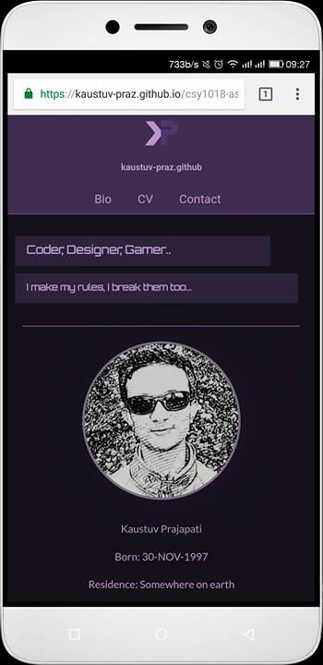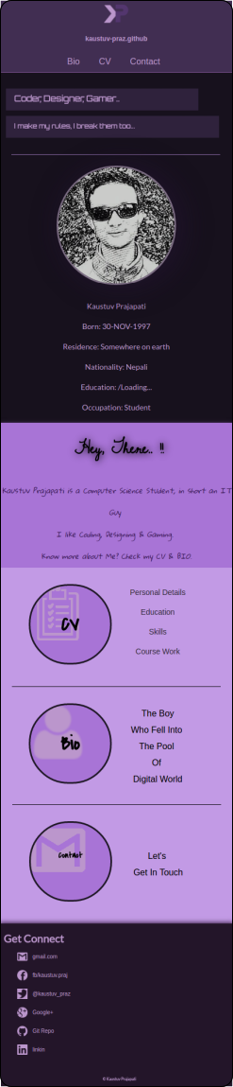All mobile view, screen resolution of width range from (320px to 425px).

Figure 2.3.7 prototype demo on Letv le-2 phone

Figure 2.3.6 Mobile view prototype (home page)

2.3.4 4th week of project development.

On 4th week I realize that the css codes are getting heavy and difficult to debug, so css code specifications is done (file handling is done), all total of 21 css files are created, for each media queries and html pages, the main.css connects all the major css files. The style.css contains design layout of all pages, laptop.css, mobile.css and tablet.css carries design responsiveness. The css file for html content management is in the file with name “html-file-name_device-responsive.css.” for example. If I need to manage the content of home (index) page for tablet view then I have to make change in css file named “index_tablet.css”.

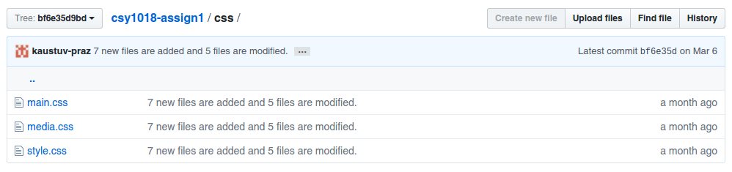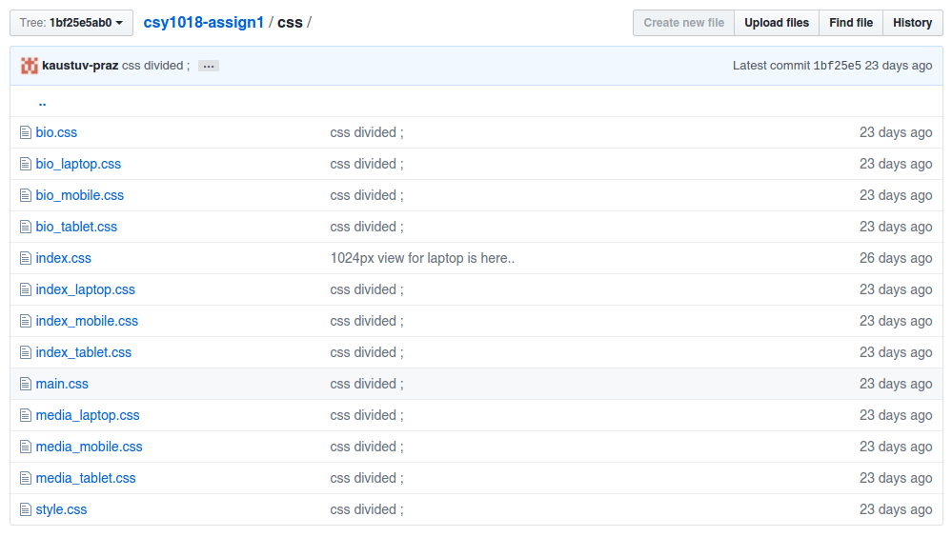Below image are 12th commit and 18th commit screenshot on github

Figure 2.3.8 Github screenshot ‘css’ folder on 12th commit

Figure 2.3.9 Github screenshot ‘css’ folder on 18th commit

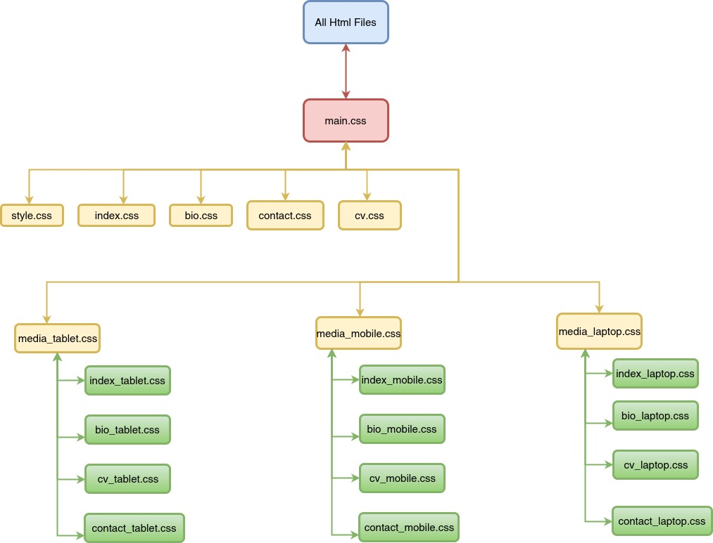

The above diagram shows how the css files are linked. All the html pages links main.css.

The main.css imports all the sub css in yellow color and each media queries related css are green in color.

2.3.5 5th week of project development.

This week the CSS was improved, code redundancy is minimized are added to make website more attractive and readable, paragraph and line spacing are managed. Also error handling was done & validation improvement was done.

It Took 5 weeks to built this website, and approximately 1.5 hour a day. Thus to complete this project it took 52.5 hour.

2.4 Error Handling

2.4.1 Header And Footer

* The header part consist of logo, git hub live URL and navigation panel.
* The footer consist of contact links, social media links and copyright info.

Problems in header and footer.

I got the header design idea form <https://joel.sh/about>, but the codes are my own. After I create the header and footer as I designed in wire frame, the website was working as I expected, but when I check the validation in HTML 5 validator.([https://validator.w3.org](https://validator.w3.org/)) it gives the error that Element <a> not allowed as child of element <ul> in this context.

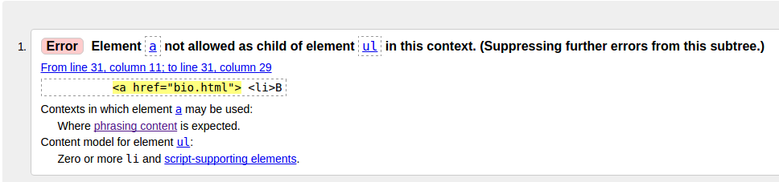To overcome this error I create a <div> inside <li> element and use <a> on that <div>.

Figure 2.4.1 error on header.

Similar problem appear on the footer <ul> as well.

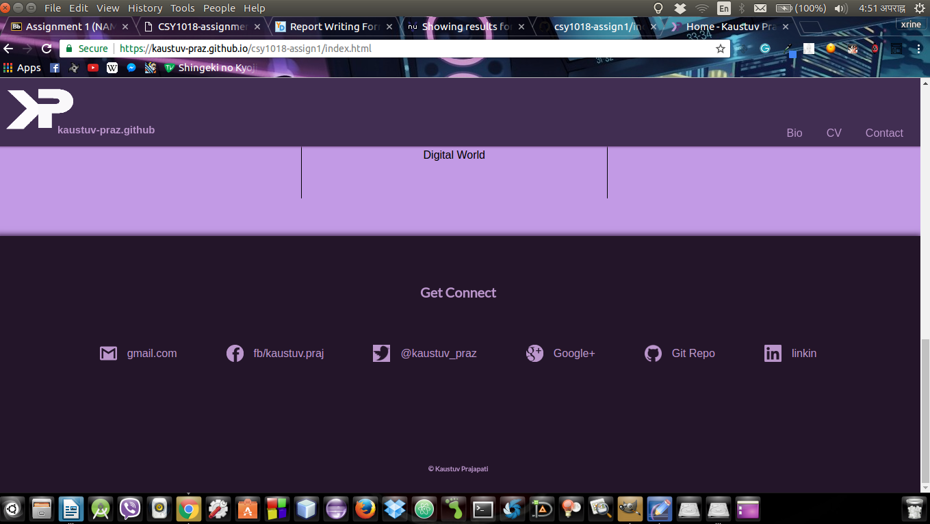In order to improve the graphic of logo the 3D-Rotation and transparency is used. There are 2 logo image on left top corner overlapping one on another for better graphic and less memory consumption. After debugging the errors and improving the color/graphics header and footer looked as in the figure xx

Figure 2.4.2 after error debugged

2.4.2 CSS Errors:

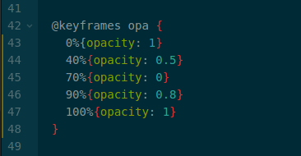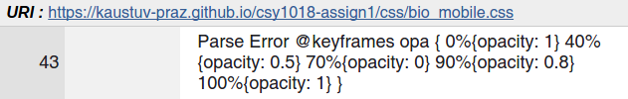The <https://jigsaw.w3.org/css-validator/> css validator shows the below codes are error.

Figure 2.4.4 Css validator shows Error on @keyframe code{ }

I found that this error was only on media queries but not on actual CSS. Thus to remove this error i removed the code form media queries and make it available on non-media queries file.

Figure 2.4.3 Atom screenshot of @keyframes code

2.5 Testing.

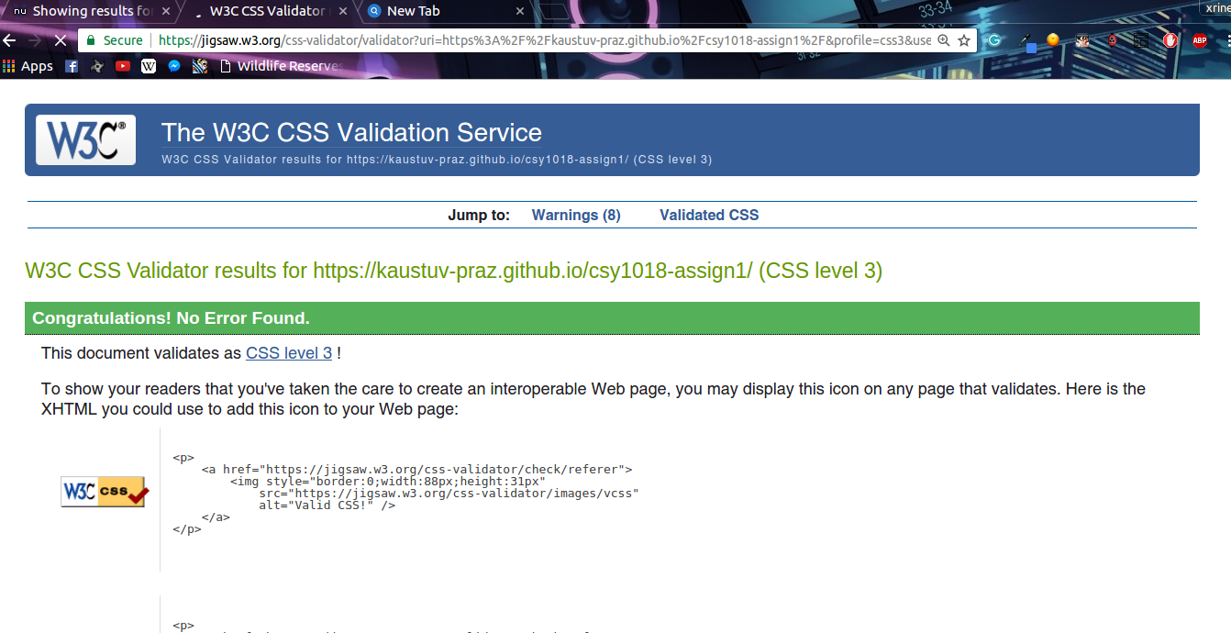Validation checking is done for both HTML-5 codes and CSS-3 codes, on <https://validator.w3.org> and <https://jigsaw.w3.org/css-validator/> respectively below image are the result of testing. Warnings are ignored.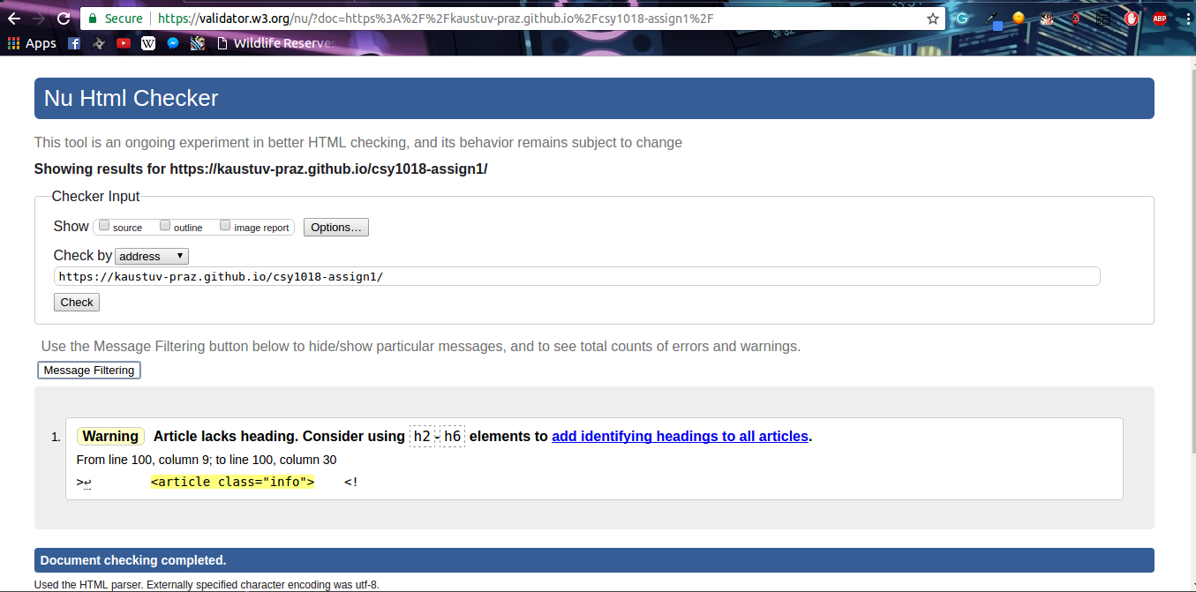

3. Prototypes

3.1 Home page (index page) prototypes.

3.1.1 Home page Desktop/Laptop view (width 1024px to 1440px)

3.1.2 Home page tablet view (Max-width: 768px)

3.1.3 Home page Mobile view (width 320px to 425px)

3.2 Biography page prototype.

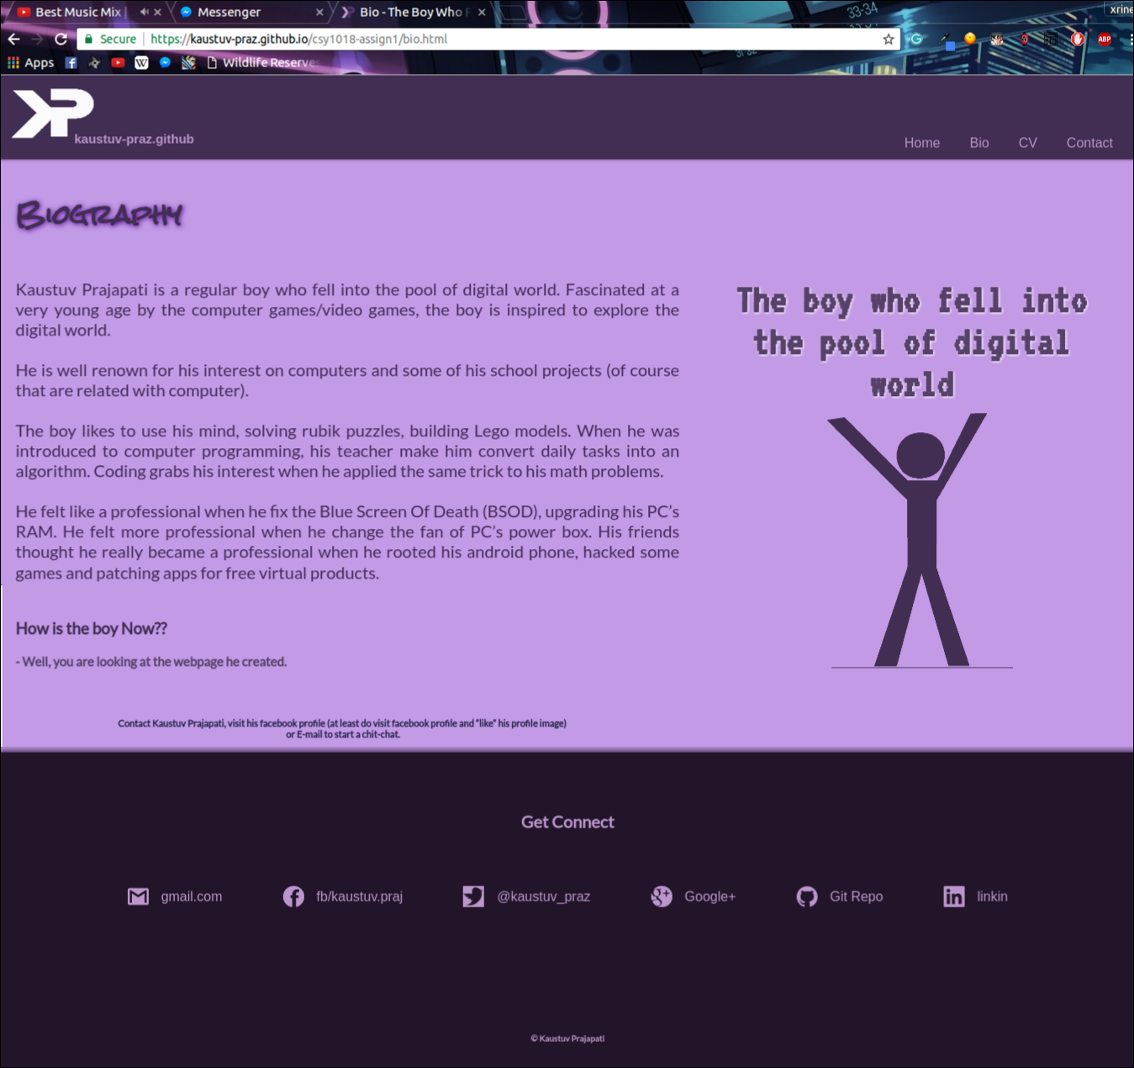3.2.1Biography page Desktop/Laptop view (width 1024px to 1440px)

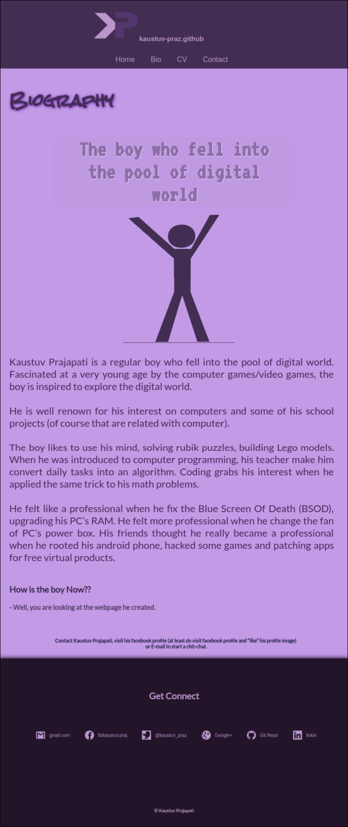3.2.2 Biography page tablet view (Max-width: 768px)

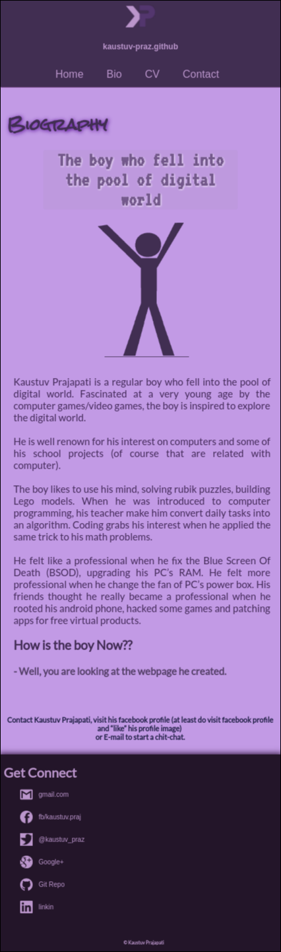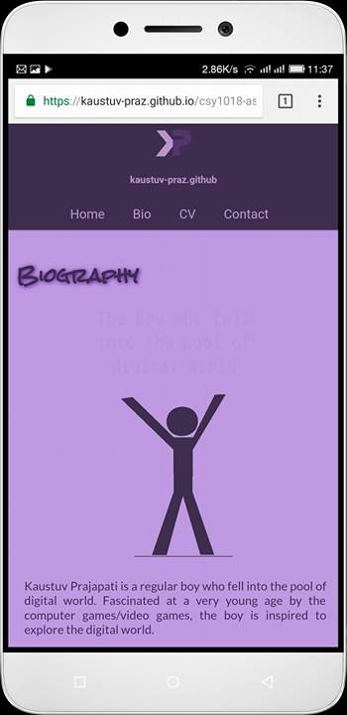3.2.3 Biography page Mobile view (width 320px to 425px)

3.3 CV page prototypes.

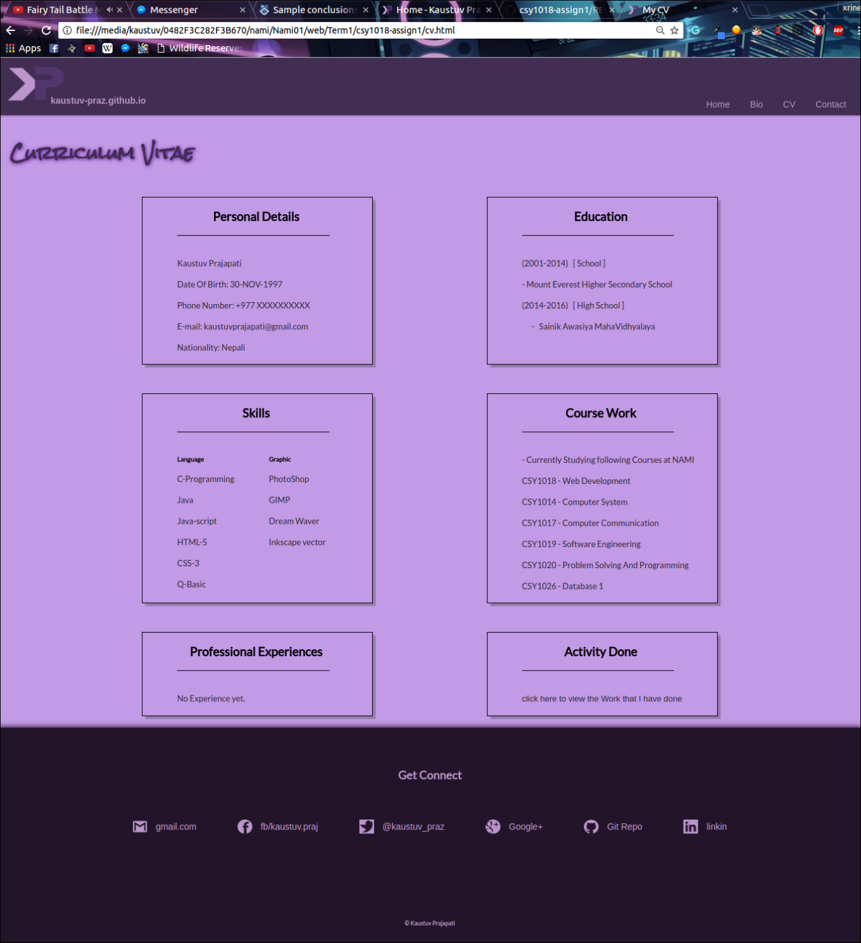3.3.1 CVpage Desktop/Laptop view (width 1024px to 1440px)

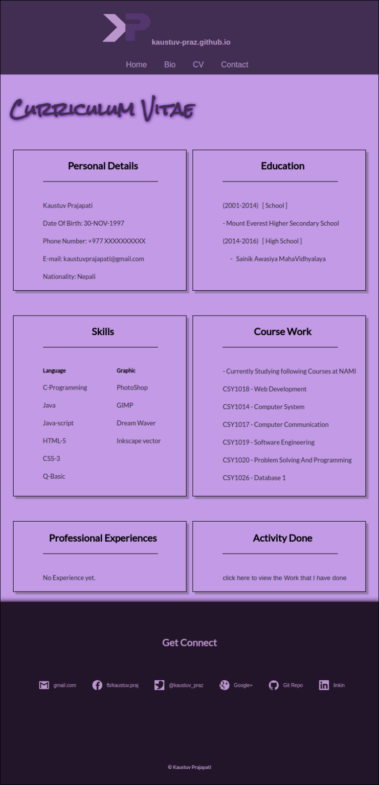3.3.2 CV page tablet view (Max-width: 768px)

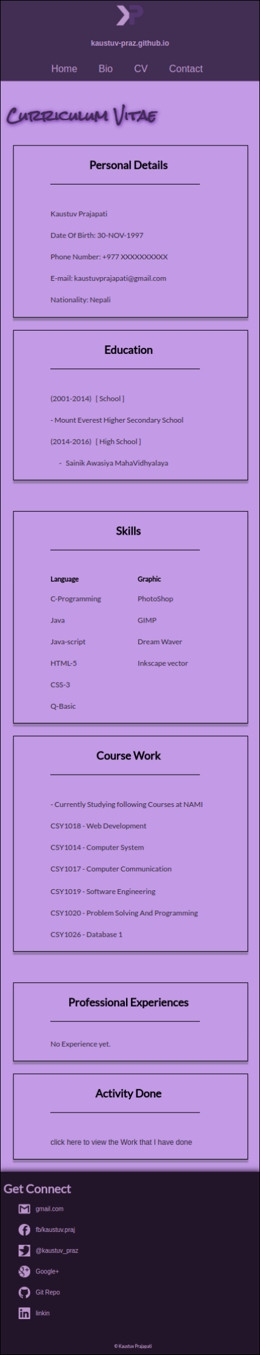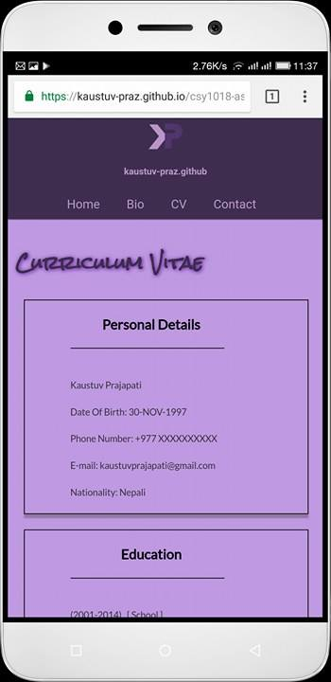3.3.3 CV page Mobile view (width 320px to 425px)

3.4 Contact page prototypes.

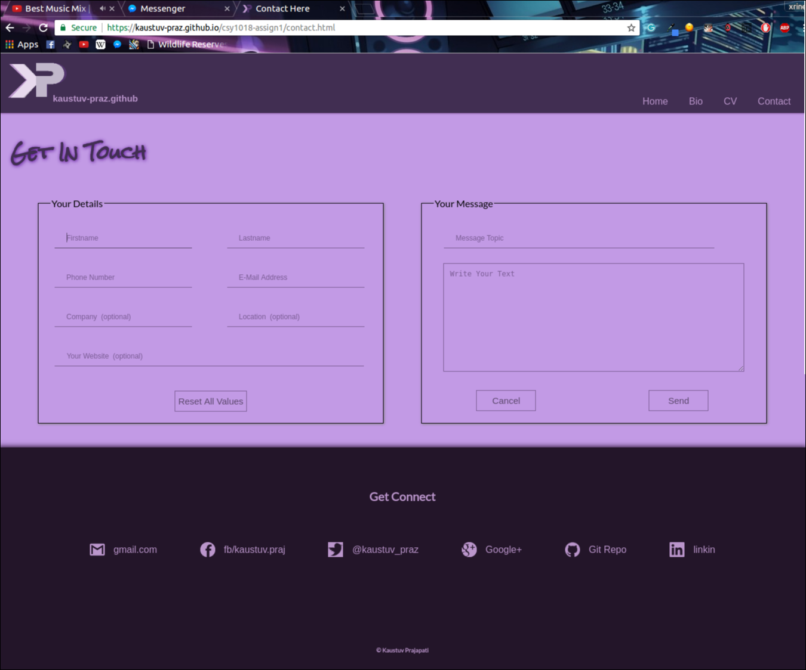3.4.1 Contact page Desktop/Laptop view (width 1024px to 1440px)

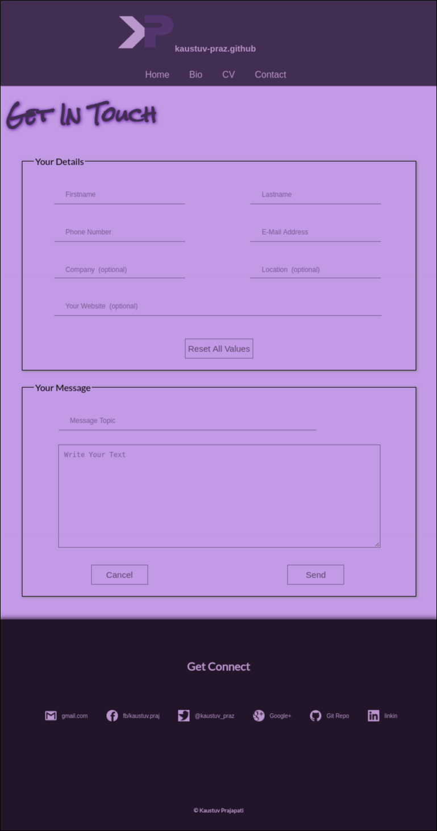3.4.2 Contact page tablet view (Max-width: 768px)

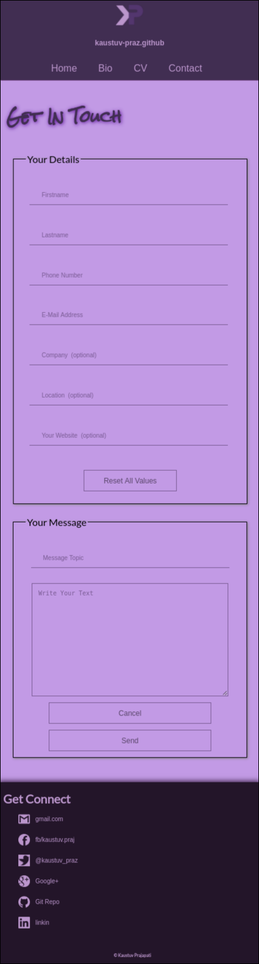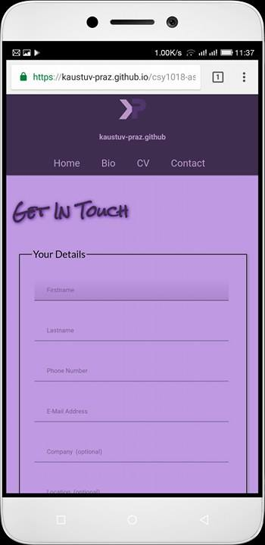3.4.3 Contact page Mobile view (width 320px to 425px)

4. Website Load Speed

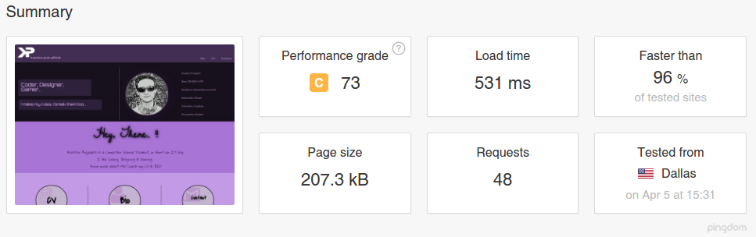I used <https://tools.pingdom.com/> website to check the load speed of my website and get the following result. The site was tested form Dallas, USA. I have compress the images that I have used in my website and use less graphic. From the Report Figure it is clear that the total size of my home page is 207.3kB which takes 531ms to Load in server at Dallas.

Figure 4.1 Screenshot from tools.pingdom.com, site load speed check

5 Good Practices followed to create this website

5.1 Use of Google API fonts.

The Google API font is used instead of device default fonts or loaded fonts. Now the font I have used will work on all the devices that are browsing my page online. It will take less data.

5.2 Use of compressed image

All the images that are used in website are compressed through photo editing software GIMP. The website size Is very Low.

5.3 User of CSS-Code animations and transitions.

CSS-Code animation and transitions are used instead of heavy GIF images, and Gradient image.

5.4 Used validation check/ testing

Validation of the website is checked through <https://validator.w3.org/> for HTML-5 codes and <https://jigsaw.w3.org/css-validator/> for CSS-3 codes.

6 Conclusion

The prototype and development of a website (portfolio website) is introduced. The website is created only by using HTML-5 & CSS-3, thus the contact form do not work. Web site is fully based on the new flex-box architecture and is made responsive to all standard screen. Hover, transitions and animation properties are used to make the website more interactive and user-friendly.

Because of limited time and restrictions, there are some features that are not added in the website, such as;

* Downloadable CV.
* Functional Contact Form.
* Scroll transitions.

7 References

pingdom. 2017. Website speed test. [ONLINE] Available at: https://tools.pingdom.com/. [Accessed 5 April 2017].

Joel Stanford. 2015. About Joel | joel.sh. [ONLINE] Available at: <https://joel.sh/about>. [Accessed 5 April 2017].

GARY SHENG. 2017. I'm Gary Sheng. [ONLINE] Available at: <http://www.garysheng.com/>. [Accessed 5 April 2017].

Rachael G. King. 2016. Professionally Social — Rachael G. King. [ONLINE] Available at: <http://www.rachaelgking.com/>. [Accessed 5 April 2017].

W3C. 2017. The W3C Markup Validation Service. [ONLINE] Available at: <https://validator.w3.org/> [Accessed 5 April 2017].

W3C. 2017. The W3C CSS Validation Service. [ONLINE] Available at: https://jigsaw.w3.org/css-validator/. [Accessed 5 April 2017].